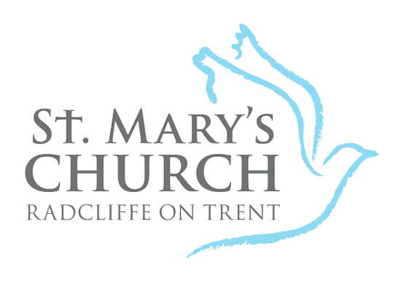

St Mary’s PCC Radcliffe on Trent
Registered Charity No 1130928

Gift Aid Declaration

My details

Title ____________ First name(s) ____________________________________________________
Surname __________________________________________________________________________

Full home address __________________________________________________________________

__________________________________________________Postcode ________________________

I would like St Mary’s Church, Radcliffe on Trent to treat as Gift Aid donations all gifts of money I have made in the past 4 years (or since 6 April ______ if more recent) and all future gifts of money I make, until I notify you otherwise.

I am a UK taxpayer and understand that if I pay less Income Tax and/or Capital Gains Tax than the amount of Gift Aid claimed on all my donations in that tax year it is my responsibility to pay any difference.

Signature ____________________________________ Date _________________________

Boost your giving by 25p of Gift Aid for every £1 you donate
Gift Aid is reclaimed by St Mary’s from the tax you pay for the current tax year.
Your address is needed to identify you as a current UK taxpayer.

What do we do with your information?
The details you give on this form will be used to administer your donations and to claim Gift Aid. Your name and postcode will be shared with HMRC as part of the claim process.
This information and a record of your donations will be retained in line with HMRC requirements (currently 7 years after your last gift-aided donation).

You are free to cancel this declaration at any time.
Please notify the church office if you:
- want to cancel this declaration
- change your name or home address
- no longer pay sufficient tax on your income and/or capital gains

If you pay Income Tax at the higher or additional rate and want to receive the additional tax relief due to you, you must include all your Gift Aid donations on your Self-Assessment tax return or ask HM Revenue and Customs to adjust your tax code.

